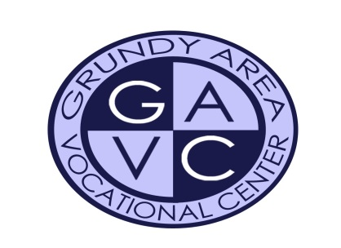
“DISCOVER A FUTURE THAT WORKS”
Serving the communities of Coal City, Gardner-South Wilmington, Minooka and Morris

Grundy Area Vocational Center
January 2022

Ms. Debra J. Eungard
1002 Union Street
Morris, IL 60450

To Whom It May Concern:

This letter is in reference for Chloe Osborn. Ms. Osborn was a student in my Early Childhood class at Grundy Area Vocational Center. Grundy Area Vocational Center is a two-year program for students that are pursuing a chosen career path. I was always very impressed with her abilities and attitude towards her education and her success. She consistently went above and beyond to get the job done accurately.

As a student, she was reliable, dependable, and personable with her peers. She definitely is a team player and is willing to do whatever it takes to get the job done. Her strong work ethic enables her to follow a project from vision to reality.

As a former kindergarten teacher, I saw many traits in Chloe that are desirable in the educational field. Ms. Osborn expressed a desire to spend time in a special education setting saying that this was where her passion was and that she had a strong desire to help students who needed extra support. While in my class, Ms. Osborn spent three days a week in a special needs lifestyles classroom which focuses on children with developmental needs or learning disabilities. She also has spent time working in a self-contained fourth/fifth math classroom and a developmental kindergarten class. The teachers that she has observed and helped were always impressed with her maturity, professionalism, and dedication to the students in their class. She was very patient, caring, and had a natural approach when handling the young children in those classes. I have witnessed Ms. Osborn’s hands-on approach when teaching to small groups and her positive style of discipline when instructing. She was always looking for ways to adapt the curriculum to fit the needs of the students she was working with. Her passion for young children is very clear in her dedication to her projects, her work samples, and her professional development.

I have no doubt that she will be an asset to any school district. I would be more than happy to discuss her qualifications with you further. Please feel free to call me at 815-942-4390.

Sincerely,

Ms. Debra Eungard
Early Childhood Instructor
Grundy Area Vocational Center
1002 Union Street, Morris, IL 60450 Phone (815) 942-4390
Fax (815) 942-6650 www.gavc-il.org

